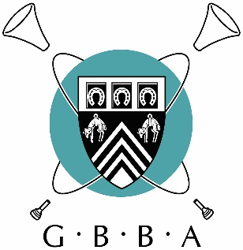
GBBA Virtual Solo and Ensemble Festival
It has been a real pleasure to adjudicate this online competition and I would like to thank every single one of you for your efforts and hard work in making this possible from the point of view of organisation and also in terms of work put in by competitors.
I am a firm believer that such online competitions are the way forward to getting us back to normality and keeping up standard of playing.
Talking of standard I have been very impressed by the level of playing in all sections you all have a lot to be proud of. Unusually the top three places in each section were very tight and that made my job difficult but with the beauty of being able to replay performances again and again I was able to determine with my results with certainty.
I would like to thank Michael Rath and Geneva Instruments for their assistance in sponsoring in part of my fee for this competition and hope this is the first of many by the GBBA. This could very much be opened up as a National event.
In summary I wish you all in these challenging times a good and healthy Christmas, and hope to see you all in the flesh as soon as restrictions allow.
Kindest Regards,
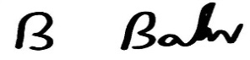

Adjudicator Dr Brett Baker December 2020

