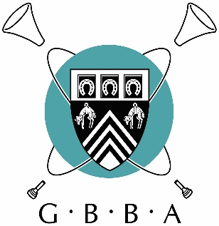
GBBA Virtual Solo and Ensemble Festival

Results for top 3 performances

Class A: 11 and Under Solo
1st | Michael McDonald | Share My Yoke by Joy Webb, arranged by Ivor Baosanko | Spennymoor Town Band
2nd | Phoebe Jones | The Enchanted Trumpet by Allen Vizzutti | Delph Youth Band
3rd | Finley South | Blues for Big Ears by Mark Nightingale | Cheltenham Silver Band

Class B: 12 to 14 Solo
1st | Toula Thomas | Red White and Blues by Leonard Bernstein | Royal Spa Brass
2nd | Sophie Danks | Flennon Study by David A Stowell | Lydbrook Training Band
3rd | Luna Arguelles | Pink Panther | Lydney Town Band

Class C: 15 to 17 Solo
1st | Louis Charles Thomas | Pas De Deux by Allen Vizzutti | Parkend Silver Band
2nd | Ella Lewis | A Nightingale Sang in Berkeley Square by Maschwitz/Sherwin, arranged by Oliver Ledbury | Bream Training Band
3rd | Alasdair Woodward | Study 14 by Bourgeois | Lydney Town Band

Class D: Open Percussion Solo
1st | Edward Jury | The Double Bubble Duchess by March Shaiman and Scott Wittman, arranged by Chris Burgess | Lydbrook Training Band

Class E: Open Slow Melody Solo
1st | Samantha Ford | Elegy, 2nd Movement from the Tenor Horn Concerto by Martin Ellerby | Filton Concert Brass
2nd | Anthony Smith | Candlelight Carol by John Rutter, arranged by David Griffiths | Filton Concert Brass
3rd | Claire Cooke | All That I Am by William Himes | Sovereign Brass

Class F: Air Varie & Technical Solo
1st | Matt Rowe | Auld Lang Syne by Simone Mantia, arranged by Keith Wilkinson | Flowers Band
2nd | Thomas Dunne | Hummingbrrd by Steven Bryant | Filton Concert Brass
3rd | David Hirst | Maid of the Mist by Herbert Clarke | Sovereign Brass

Class G: Open Ensemble
1st | Samantha Ford and Thomas Dunne (duet) | Sontata in Canon No.1, Movement 3 by Telemann | Filton Concert Brass
2nd | Elizabeth Forster and Eleanor Forster (duet) | Blues in Bb by Jack Gale | Forest of Dean Brass and Bream Training Band
3rd | H’6tet (sextet) | The Melody Shope by Karl King, arranged by Micah Roberts | H’6tet

Congratulations to all prize winners and thank you to everyone who entered.
Feedback from adjudicator Dr Brett Baker will be sent to individuals.
Thank you to Dr Brett Baker for adjudicating, and to Michael Rath and GENEVA Instruments who sponsored this contest.

